EXPERIMENT 5
FLIGHT BOOKING SYSTEM
AIM:
To design and develop a web-based Flight Reservation System using HTML, CSS, and JavaScript that allows users to log in, search for flights, book tickets, make payments, view and print tickets, cancel tickets, and provide feedback.
CODE:
<!DOCTYPE html>
<html>
<head>
<title>Flight Reservation</title>
<style>
body{font-family:Arial;text-align:center;background:#eee}
div{background:white;padding:20px;margin:30px auto;width:350px}
input,select,button{padding:10px;margin:5px;width:90%}
button{background:#1670a8;color:white;border:0}
</style>
</head>
<body>
<div id="login">
<h2>✈️ Flight Reservation</h2>
<input id="u" placeholder="Username">
<input id="p" type="password" placeholder="Password">
<button onclick="login()">Login</button>
</div>
<div id="app" style="display:none">
<h2>Search Flight</h2>
<input id="from" placeholder="From">
<input id="to" placeholder="To">
<input id="date" type="date">
<select id="cls">
<option>Economy</option>
<option>Business</option>
</select>
<button onclick="search()">Search</button>
<p id="result"></p>
<button onclick="ticket()">My Ticket</button>
<button onclick="cancel()">Cancel Ticket</button>
<p id="output"></p>
</div>
<script>
let pnr="";
function login(){
if(u.value=="admin"&&p.value=="1234"){
login.style.display="none";
app.style.display="block";
}else alert("Invalid Login");
}
function search(){
result.innerHTML=
"✈️ Air India<br>"+from.value+" → "+to.value+
"<br>Fare: ₹5500<br>Seats: 20"+
'<br><button onclick="book()">Book Ticket</button>';
}
function book(){
pnr=Math.floor(100000+Math.random()*900000);
alert("Payment Successful!\nPNR: "+pnr);
ticket();
}
function ticket(){
output.innerHTML=
"🎫 PNR: "+pnr+
"<br>Flight: Air India"+
"<br>Status: CONFIRMED"+
'<br><button onclick="print()">Print Ticket</button>';
}
function print(){window.print()}
function cancel(){
if(pnr){alert("Ticket Cancelled");pnr=""}
else alert("No Ticket Found");
}
</script>
</body>
</html>
OUTPUT:
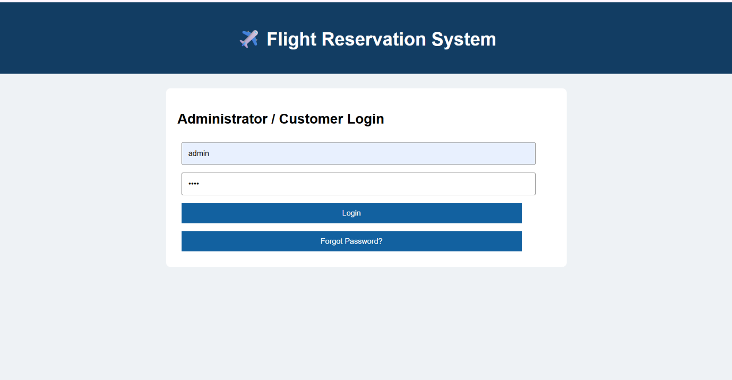
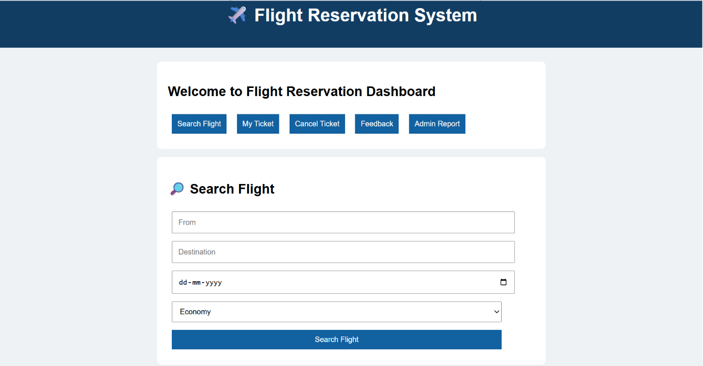
RESULT:
Thus, the Flight Reservation System was successfully designed and implemented. The system allows users to search and book flights, generate a PNR number, view booking details, print tickets, cancel tickets, and submit feedback through a simple and user-friendly web interface.

